Access Center Call Flows

Software Requirements Specification Document

Prepared by Martin Ganen-Villa

August 5, 2025

**Table of Contents**

**Introduction 3**

1.1 Purpose 3

1.2 Intended Audience 3

1.3 Intended Use 3

1.4 Product Scope 3

1.5 Definitions and Acronyms 3

**Overall Description 3**

2.1 User Characteristics 3

2.2 Assumptions and Dependencies 4

**System Features and Requirements 4**

3.1 Functional Requirements 4

3.1.1 User Access and Navigation 4

3.1.2 Decision Flow Logic 4

3.1.3 Usability 5

3.1.4 Error Handling 5

3.2 Non-Functional Requirements 5

3.2.1 Performance Requirements 5

3.2.2 Availability 6

3.2.3 Security 6

3.2.4 Usability 6

3.3 External Interface Requirements 6

3.3.1 User Interface 6

3.3.2 Software Interface 6

3.3.3 Communications Interface 6

3.4 Design Constraints and Limitations 6

**Other Requirements 6**

4.1 Database Requirements 6

4.2 Legal and Regulatory Requirements 7

**Appendices 7**

5.1 FAQ 7

# Introduction

## 1.1 Purpose

The purpose of this document is to present a detailed description of the Access Center Call Flow. It will explain the purpose and features and interface of the site, what the site will do, the constraints under which it must operate.

## 1.2 Intended Audience

This document is intended for the NCH Access Center and the site's corresponding developers. The Access Center Representatives will use the site as a guide when on call with patients. The developers will be responsible for producing, maintaining, and further developing of the site.

## 1.3 Intended Use

The site will be used internally by NCH Access Center employees to use as a guide while on call with patients to help direct them to the correct department. The overall goal is to streamline workflows while decreasing total overall call time with simple guides.

## 1.4 Product Scope

The main objective of the site is to decrease call times and to provide representatives with an easier way of directing patients to their desired destination or providing them with a solution quicker. This will ultimately lead to a more efficient process with less time spent on call as representatives have checklists of what they need before moving on to any next steps with instructions given directly from different NCH services.

## 1.5 Definitions and Acronyms

* Patient → Person who initiates the call looking for a solution
* Representative/User → Access Center employee on the phone with the patient
* Developer → Person(s) actively working on creating the site
* HIPAA → The Health Insurance Portability and Accountability Act is a federal law that sets national standards for protecting patient information.

# Overall Description

## 2.1 User Characteristics

The primary, and only, users of the system are Access Center representatives, who are responsible for handling calls coming from patients. These representatives serve as the first point of contact for patients seeking information, services, or guidance regarding their healthcare needs.

Access Center representatives will be using the website in real time alongside the call with the patient. The site is designed to streamline their workflow by helping them quickly determine the service the patient is asking for. This can include reaching out to a general surgery department, making an appointment, or asking common questions.

Given the guides provided by individual departments and the simplicity of the site, there’s a guarantee that patients will be routed correctly, reducing callbacks and additional errors.

## 2.2 Assumptions and Dependencies

* The website will be kept internal to only be accessed by Access Center employees and developers through a shared drive.
* The site currently does not run on any external or third party services.
* Reported issues will be sent to the Access Center team and/or developers to resolve the issue.
* All pages redirect to the appropriate solution

# System Features and Requirements

## 3.1 Functional Requirements

### 3.1.1 User Access and Navigation

1. Given the user has opened the site, they are presented with a starting point which separates NCH Specialty services from primary care, along with a Hospital Discharge Survey
2. Given the user navigates to the appropriate section, the page presents a list of different services the user can select.
3. Given the user makes an error, there’s a button that can direct the user back to the home page or to a previous step.

### 3.1.2 Decision Flow Logic

1. Given that a patient describes their needs, when the representative selects the appropriate matching option, then the page should guide them down the appropriate avenue.
2. Given that the representative is not sure where to go once in a specific service, there is a button which links to an image of the guide given by the department, demonstrating the appropriate workflow
3. Given a decision path ends in a solution, when the user reaches the final step, then the page displays the appropriate final actions to take.
4. Given multiple possible solutions to choose from, when the representative is presented with the options, then the system should provide clear criteria for selecting between them.

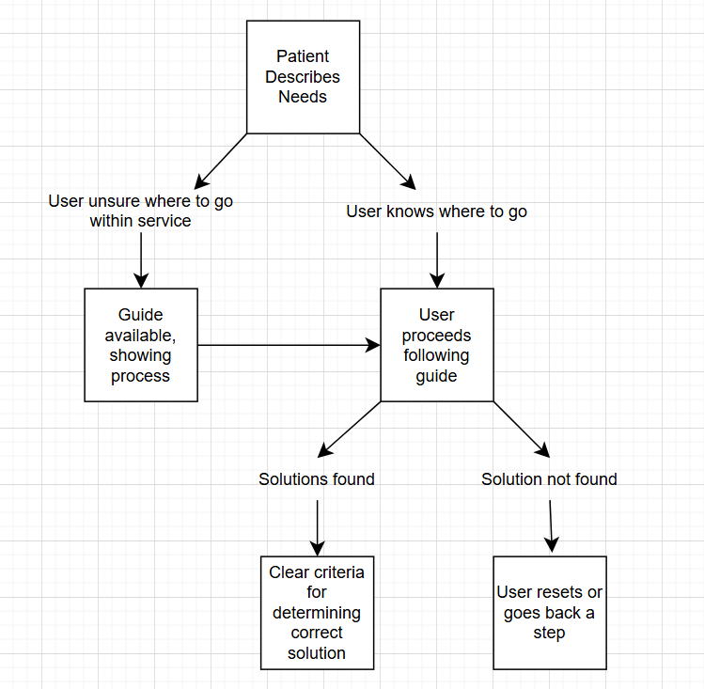

### 3.1.3 Usability

1. Given the user has access to any modern browser, when the page loads, then the user will have access to all functionality without issues.

### 3.1.4 Error Handling

1. Given a user encounters an issue with the page (broken link, incorrect workflow diagram, etc.), when the error occurs, then the user can find a button on the page where they can fill out a form to report an issue.

## 3.2 Non-Functional Requirements

### 3.2.1 Performance Requirements

1. The landing page must load in a short amount of time (<2 seconds) under normal conditions.
2. The subsequent pages that the user clicks on must load in a similar amount of time.

### 3.2.2 Availability

1. The page must be available to use for 99% of the time during business hours.

### 3.2.3 Security

1. The page will only be accessed internally via shared drive access on the company’s network.

### 3.2.4 Usability

1. The site must be very simple to use and intuitive, requiring no more than 30 minutes of training for new employees

## 3.3 External Interface Requirements

### 3.3.1 User Interface

1. The site shall have a clean and intuitive interface which guides the representative through decision flows.
2. All interactive elements should be clearly labeled.
3. The site must have a consistent layout and design patterns.

### 3.3.2 Software Interface

1. The site shall run on any modern browser, mainly Microsoft Edge.

### 3.3.3 Communications Interface

1. The site shall operate within the company’s network to ensure secure access.

## 3.4 Design Constraints and Limitations

* The site can only be accessed on the internal network, limiting the ability of remote employees to access the site.
* There are no third party integrations, needing appointments or other services to be done through external software.
* Given the nature of the userbase, UI design must remain simple with a minimal learning curve and clear language.
* The site must not store patient information in accordance with law, therefore cannot personalize responses.
* Decision flows are hard coded, requiring developers to update any departmental changes.

# Other Requirements

## 4.1 Database Requirements

* The current version of the site does not include a database.
* All decision flows are handled client-side.

## 4.2 Legal and Regulatory Requirements

* The system must comply with internal IT policies regarding user access and internal-only systems.
* HIPAA compliance is not required as no personal information is collected; however any future changes may require this.

# Appendices

## 5.1 FAQ

* Q: Does the site store any personal data?
  + A: No, the site does not store, transmit, or process any patient data.
* Q: How is the site accessed:
  + A: The site can be accessed via a shared drive that can only be accessed through the company’s internal network.
* Q: What should a user do if they’re not sure what the patient is asking for?
  + A: The user should find the “Guidelines” button which will open a guide describing what the representative should do based on the patient’s needs.
* Q: What happens if a user discovers an issue with the site?
  + A: Should a user discover an issue, they should fill out an issue report which can be accessed by a button on the top-right of the page which will inform developers on what to fix.
* Q: Why is HIPAA important?
  + A: HIPAA protects patient privacy as it states that health information cannot be shared with anyone who isn’t directly authorized to view it, building trust between patient and provider.
* Q: If an employee works from home, how can they access the site?
  + A: The employee must be working on a company provided computer that has constant access to the network.